When I [announced the last release of ggforce](https://www.data-imaginist.com/2019/the-ggforce-awakens-again/)  
We hinted that We would like to transition to a more piecemeal release habit and  
avoid those monster releases that the last one was. True to my word, I am now  
thrilled to announce that a new version of ggforce is available on CRAN for your  
general consumption. It goes without saying that this release contains fewer  
features and fixes than the last one, but those it packs are considerable so  
let’s get to it.

**Build for gganimate**

The [gganimate](https://gganimate.com/) package facilitates the creation of  
animations from ggplot2 plots. It is build to be as general purpose as possible,  
but it still makes a few assumptions about how the layers in the plot behaves.  
Some of these assumptions where not met in a few of the ggforce geoms (the  
technical explanation was that some stats and geoms stripped group information  
from the data which trips up gganimate). This has been rectified in the new  
version of ggforce and all geoms should now be ready for use with gganimate  
(please report back if you run into any problems).

**Facets for the people**

The remainder of the release centers around facets and a few geoms that has been  
made specifically for them.

**Enter the matrix**

The biggest news is undoubtedly the introduction of facet_matrix(), a facet  
that allows you to create a grid of panels with different data columns in the  
different rows and columns of the grid. Examples of such arrangements are known  
as scatterplot matrices and pairs plots, but these are just a subset of the  
general approach.

Before we go on I will, in the interest of full disclosure, mention that certain  
types of scatterplot matrices have been possible for a long time. Most powerful  
has perhaps been the [ggpairs() function in GGally](https://ggobi.github.io/ggally/#ggallyggpairs)  
that provides an API for pairs plots build on top of ggplot2. More low-level and  
limited has been the possibility of converting the data to a long format by  
stacking the columns of interest and using facet_grid(). The latter approach  
requires that all columns of interest are of the same type and further moves a  
crucial operation of the visualization out of the visualization API. The former  
approach, while powerful, is a wrapper around ggplot2 rather than an extension  
of the API. This means that you are limited to what the wrapper function  
provides thus loosing the flexibility of the ggplot2 API. A plurality of choices  
is good though, and I’m certain that there are rooms for all approaches to  
thrive.

To show off facet_matrix() I’ll start with a standard use of scatterplot  
matrices, namely plotting multiple components from a PCA analysis against each  
other.

library(recipes)

# Data described here: <https://bookdown.org/max/FES/chicago-intro.html>

load(url("<https://github.com/topepo/FES/blob/master/Data_Sets/Chicago_trains/chicago.RData?raw=true>"))

pca_on_stations <-

recipe(~ ., data = training %>% select(starts_with("l14_"))) %>%

step_center(all_predictors()) %>%

step_scale(all_predictors()) %>%

step_pca(all_predictors(), num_comp = 5) %>%

prep() %>%

juice()

pca_on_stations

## # A tibble: 5,698 x 5

## PC1 PC2 PC3 PC4 PC5

##

## 1 1.37 4.41 0.347 0.150 0.631

## 2 1.86 4.50 0.618 0.161 0.523

## 3 2.03 4.50 0.569 0.0468 0.543

## 4 2.37 4.43 0.498 -0.209 0.559

## 5 2.37 4.13 0.422 -0.745 0.482

## 6 -15.7 1.23 0.0164 -0.180 1.04

## 7 -21.2 0.771 -0.653 1.35 1.23

## 8 -8.45 2.36 1.07 -0.143 0.404

## 9 3.04 4.30 0.555 -0.0476 0.548

## 10 2.98 4.45 0.409 -0.125 0.677

## # … with 5,688 more rows

library(ggforce)

ggplot(pca_on_stations, aes(x = .panel_x, y = .panel_y)) +

geom_point(alpha = 0.2, shape = 16, size = 0.5) +

facet_matrix(vars(everything()))

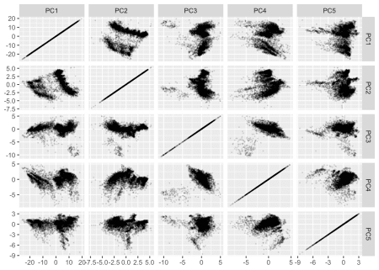

Let’s walk through that last piece of code. We construct a standard ggplot using  
geom_point() but we map x and y to .panel_x and .panel_y. These are  
placeholders created by facet_matrix(). Lastly we add the facet_matrix()  
specification. At a minimum we’ll need to specify which columns to use. For that  
we can use standard tidyselect syntax as known from e.g. dplyr::select() (here  
we use everything() to select all columns).

Now, the above plot has some obvious shortcomings. The diagonal is pretty  
useless for starters, and it is often that these panels are used to plot the  
distributions of the individual variables. Using e.g. geom_density() won’t  
work as it always start at 0, thus messing with the y-scale of each row. ggforce  
provides two new geoms tailored for the diagonal: geom_autodensity() and  
geom_autohistogram() which automatically positions itself inside the panel  
without affecting the y-scale. We’d still need to have this geom only in the  
diagonal, but facet_matrix() provides exactly this sort of control:

ggplot(pca_on_stations, aes(x = .panel_x, y = .panel_y)) +

geom_point(alpha = 0.2, shape = 16, size = 0.5) +

geom_autodensity() +

facet_matrix(vars(everything()), layer.diag = 2)

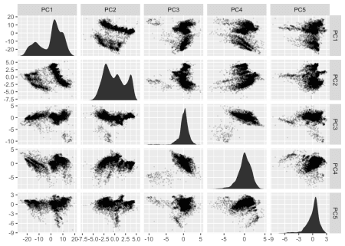

As the y-scale no longer affects the diagonal we’ll emphasize this by removing  
the horizontal grid lines there:

ggplot(pca_on_stations, aes(x = .panel_x, y = .panel_y)) +

geom_point(alpha = 0.2, shape = 16, size = 0.5) +

geom_autodensity() +

facet_matrix(vars(everything()), layer.diag = 2, grid.y.diag = FALSE)

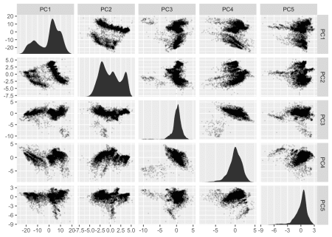

There is still some redundancy left. As the grid is symmetrical the upper and  
lower triangle shows basically the same (with flipped axes). We could add some  
insight by using another geom in one of the areas that showed some summary  
statistic instead:

ggplot(pca_on_stations, aes(x = .panel_x, y = .panel_y)) +

geom_point(alpha = 0.2, shape = 16, size = 0.5) +

geom_autodensity() +

geom_density2d() +

facet_matrix(vars(everything()), layer.diag = 2, layer.upper = 3,

grid.y.diag = FALSE)

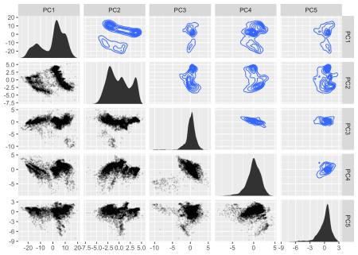

While we could call this a day and be pretty pleased with ourselves, I’ll need  
to show the final party trick of facet_matrix(). The above example was kind of  
easy because all the variables were continuous. What if we had a mix?

ggplot(mpg, aes(x = .panel_x, y = .panel_y)) +

geom_point(shape = 16, size = 0.5) +

facet_matrix(vars(fl, displ, hwy))

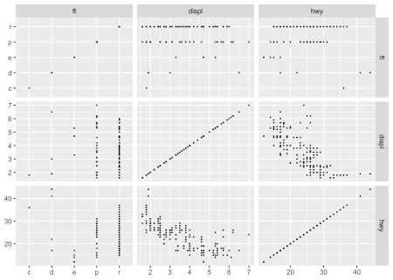

As we can see facet_matrix() itself handles the mix of scale types quite well,  
but geom_point() is not that telling when used on a mix of continuous and  
discrete position scales. ggforce handles this by providing a new position  
adjustment (position_auto()) that jitters the data based on the scale types.  
For continuous vs discrete it does a sina-like jitter, whereas for discrete vs  
discrete it jitters inside a disc (continuous vs continuous makes no jitter):

ggplot(mpg, aes(x = .panel_x, y = .panel_y)) +

geom_point(shape = 16, size = 0.5, position = 'auto') +

facet_matrix(vars(fl, displ, hwy))

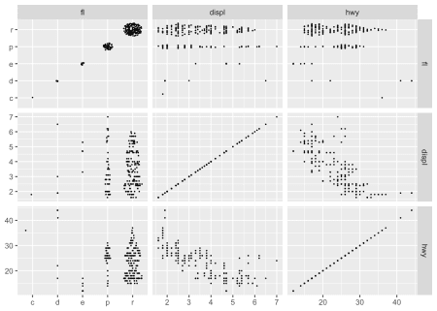

geom_autodensity() and geom_autohistogram() also knows how to handle both  
discrete and continuous data, so these can be used safely in all circumstances  
(here also showing that you can of course also map other aesthetics):

ggplot(mpg, aes(x = .panel_x, y = .panel_y, fill = drv, colour = drv)) +

geom_point(shape = 16, size = 0.5, position = 'auto') +

geom_autodensity(alpha = 0.3, colour = NA, position = 'identity') +

facet_matrix(vars(fl, displ, hwy), layer.diag = 2)

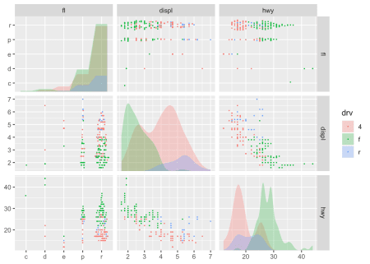

Lastly, if you need to use a geom that only makes sense with a specific  
combination of scales, you can pick these layers directly, though you may end up  
fiddling a bit to get all the right layers where you want them:

ggplot(mpg, aes(x = .panel_x, y = .panel_y, fill = drv, colour = drv)) +

geom_point(shape = 16, size = 0.5, position = 'auto') +

geom_autodensity(alpha = 0.3, colour = NA, position = 'identity') +

geom_smooth(aes(colour = NULL, fill = NULL)) +

facet_matrix(vars(fl, displ, hwy), layer.diag = 2, layer.continuous = TRUE,

layer.mixed = -3, layer.discrete = -3)

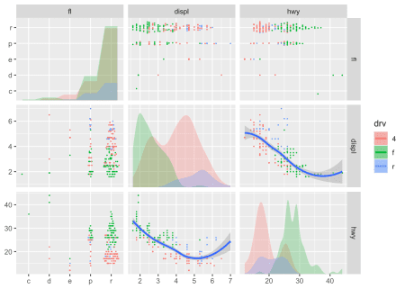

The last example I’m going to show, is simply that you don’t have to create  
symmetric grids. By default facet_matrix() sets the column selection to be the  
same as the row selection, but you can overwrite that:

ggplot(mpg, aes(x = .panel_x, y = .panel_y)) +

geom_point(shape = 16, size = 0.5, position = 'auto') +

facet_matrix(vars(manufacturer, hwy), vars(drv, cty))

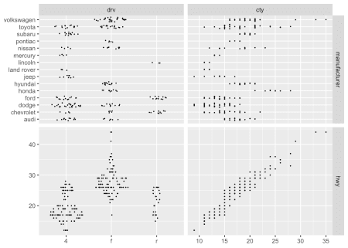

As you can hopefully appreciate, facet_matrix() is maximally flexible, while  
keeping the API of the standard use cases relatively clean. The lack of a  
ggplot2-like API for plotting different variables against each others in a grid  
has been a major annoyance for me, and I’m very pleased with how I finally  
solved it—I hope you’ll put it to good use as well.

**Who needs two dimensions anyway?**

The last new pack of facets are more benign, but something repeatedly requested.  
facet_row() and it’s cousin facet_col() are one-dimensional mixes of  
facet_grid() and facet_wrap(). They arrange the panels in a single row or  
single column respectively (like setting nrow or ncol to 1 in  
facet_wrap()), but by doing so allows the addition of a space argument as  
known from facet_grid(). In contrast to using facet_grid() with a single  
column or row, these new facets retain the facet_wrap() ability of having  
completely separate scale ranges as well as positioning the facet strip  
wherever you please:

ggplot(mpg) +

geom_bar(aes(x = manufacturer)) +

facet_col(~drv, scales = 'free_y', space = 'free', labeller = label_both) +

coord_flip()

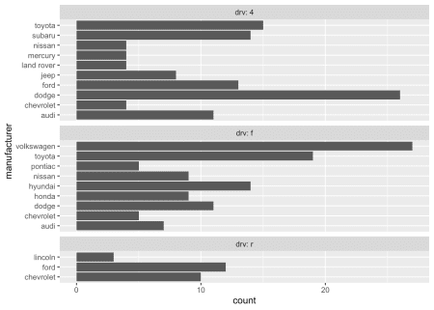

So, these were the flurry of facets I was going to bring you today—I hope you’ll  
put them to good use and create some awesome visualizations with them.